

**Assignment: 5 Fall 2025 NS 1001 Applied physics**

**Due Date: 01-12-2025 (For Sections have Classes Monday)**

**Due Date: 02-12-2025 (For Sections have Classes on Tuesday)**

***Dear students you do not need to submit the assignment at GCR, only hard submission in handwriting is required. You will have assignment-based quiz from this assignment in your respective classes according to your timetable on campus. No late submission will be accepted.***

**CLO:3 Define basic concepts of semiconductor physics to help them in advance course of digital logic design..**

**Q.1.** Determine the resistance of the circuit in Figure 1 as seen from the voltage source.



Figure 1

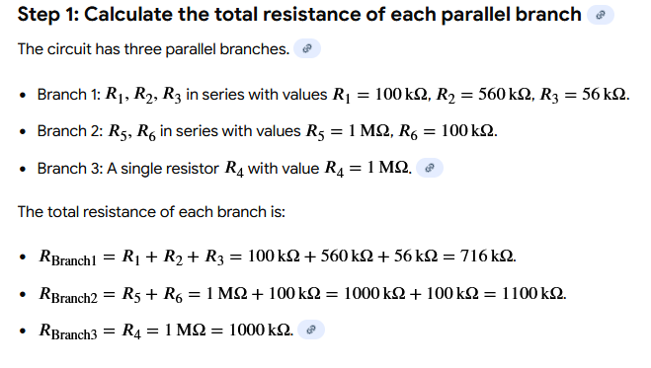

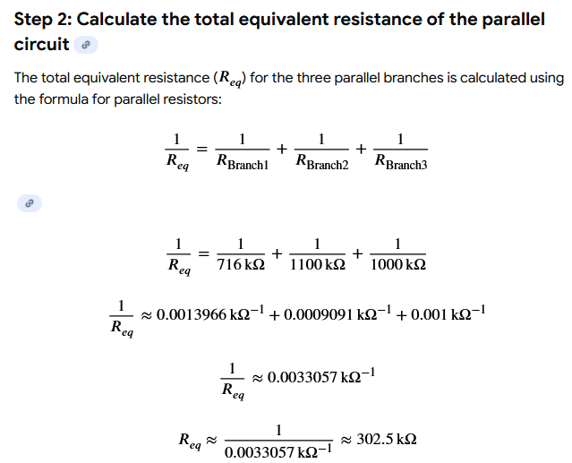

**Q.2.** Determine the voltage, VAB, in Figure 2.



Figure 2



**Q.3.** What is the voltage across each resistor in Figure 3 with 10 V between A and B?



Figure 3





**Q.4.** Find IT and Vout in the Figure 4.



Figure 4







**Q.5. For the network of Fig. 5: (a) Determine RT. (b) Find Is, I1, and I2. (c) Calculate Va.**



Figure 5



**Q6. For the network of Fig. 6: (a) Determine the currents Is, I1, I3, and I4. (b) Calculate Va and Vbc.**



Figure 6

**Q7. For the network of Fig. 7:**

**(a) Determine the current I1.**

**(b) Calculate the currents I2 and I3.**

**(c) Determine the voltage levels Va and Vb.**



Figure 7

